Communication Requirements for
Legitimate Relationships

P2R1 MiM 4.0

Amendment History:

Version | Author | Date | Amendment History
0.1 | Tom Parker/ Malcolm Oswald/ Sarah Bagshaw | 16/03/05 | First draft
0.2 | Malcolm Oswald/Tom Parker/Sarah Bagshaw | 13/04/05 | Changes to support historic LR requirements.

Approvals
This document requires the following approvals.

Name | Signature | Title | Date of Issue | Version
Andy Truscott |  | Head of IG
Max Jones |  | Programme Head

Document Location
This document is only valid on the day it was printed. Please contact the Document Controller for location details or printing problems.

This is a controlled document. On receipt of a new version, please destroy all previous versions (unless a specified earlier version is in use throughout the project).
© Crown Copyright 2005

Unauthorised copying, distribution, renting, lending or communicating to the public of all or a substantial part of any Crown Copyright material is prohibited. Licences for the use of Crown Copyright material are available from Her Majesty's Stationery Office, at http://www.hmso.gov.uk (click on 'Click-Use licences').
All trade marks and logos are the property of their respective owners. The use of any trade mark or logo without the prior written permission of the relevant owner is prohibited.

Contents

1 Purpose 7
2 Create New Legitimate Relationship 8
2.1 Description 8
2.2 Clinical Scenario 8
2.3 Activity diagram 8
2.4 Business Transactions 9
2.4.1 Create Legitimate Relationship Request 9
2.4.2 Legitimate Relationship Creation Response 20
3 Legitimate Relationship Status Change 23
3.1 Description 23
3.2 Clinical Scenario 23
3.3 Activity diagram 24
3.4 Business Transactions 24
3.4.1 Legitimate Relationship Status Change Request 24
3.4.2 Legitimate Relationship Status Change Response 30
4 Legitimate Relationship Confirmation Request 34
4.1 Description 34
4.2 Clinical Scenario 34
4.3 Activity diagram 35
4.4 Business Transactions 35
4.4.1 Legitimate Relationship Confirmation Request 36
4.4.2 Legitimate Relationship Confirmation Short Response 43
4.4.3 Legitimate Relationship Confirmation History Response 45
5 Legitimate Relationship Batch Confirmation Request 49
5.1 Description 49
5.2 Clinical Scenario 49
5.3 Activity diagram 50
5.4 Business Transactions 50
5.4.1 Legitimate Relationship Batch Confirmation Request 51
5.4.2 Legitimate Relationship Batch Confirmation Response 57
6 Obtain Legitimate Relationship Details 62
6.1 Description 62
6.2 Clinical Scenario 62
6.3 Activity diagram 63
6.4 Business Transactions 63
6.4.1 Legitimate Relationship Record Details Request 63
6.4.2 Simple Legitimate Relationship Record Details Response 70
6.4.3 Complete Legitimate Relationship Record Details Response 76
7 Workgroup Membership Management: Please note that these messages will not be in MiM until September 2005. 90
8 Identify User Role Profiles 90
8.1 Description 90
8.2 Clinical Scenario 90
8.3 Activity diagram 91
8.4 Business Transactions 91
8.4.1 Identify User Role Profiles Request 91
8.4.2 Identify User Role Profiles Response 94
9 Query User Workgroup Membership 97
9.1 Description 97
9.2 Clinical Scenario 98
9.3 Activity diagram 98
9.4 Business Transactions 99
9.4.1 Query User Workgroup Membership Request 99
9.4.2 Query User Workgroup Membership Response 101
10 Add User to Workgroup 104
10.1 Description 104
10.2 Clinical Scenario 104
10.3 Activity diagram 106
10.4 Business Transactions 106
10.4.1 Add User to Workgroup Request 106
10.4.2 Add User to Workgroup Response 109
11 Remove User from Workgroup 112
11.1 Description 112
11.2 Clinical Scenario 112
11.3 Activity diagram 113
11.4 Business Transactions 113
11.4.1 Remove User from Workgroup Request 113
11.4.2 Remove User from Workgroup Response 116

Purpose

- This document describes in detail the message content of each of the business communications outlined in the Legitimate Relationships Detailed Business Analysis report. There shall be one W5 for each W3. Where there are many business processes, these shall be encompassed in separate sections of a single W5
- It forms the deliverable for each Work Stream Domain – Business Communication definition and refinement stage (W5) in accordance with the Communications & Messaging Programme Development methodology
- It lists the data items, their inter-relationships, grouping, data typing, validation rules and coding (where appropriate)
- It lists, at a data level, any issues that have been identified that would hinder development and/or implementation
- It provides a means to communicate the proposed message content to the Programme’s Technical (message development) team to enable them to form the required HL7 message constructs; and similarly to the suppliers that will have to build them

Extracts from W3 Detailed Business Analysis Document:

Issue: Legitimate Relationships are one component of the overall security mechanism of the national systems. The relationship between Legitimate Relationships, Role Profiles, Sealed Envelopes, etc., must be clearly understood, and defined in terms of an end-to-end business environment, to prevent gaps occurring in the business process, and to ensure that conflicts in functionality are not introduced into the individual component processes.

Assumption: Validation of the rights and privileges of the individual or application affecting Legitimate Relationships records, when performed by the managing application, will be performed as part of its normal functionality. These validation processes and associated messages are therefore not included in this document.

Create New Legitimate Relationship

Description
Whenever a need arises to set-up a Legitimate Relationship between a patient and a User Role Profile (NCRS User),Workgroup or Other Person, a record of the relationship is created on the appropriate national system. A request is generated, either by an individual user, or from an automated source (depending on business rules embedded in the system functionality), and a record of the relationship details is placed on the appropriate system database.

Assumption: For this document, the national systems are seen as a single entity, and no account is taken of any data transfer or communication across the national system component applications.

Clinical Scenario
To be determined, pending design of the end-to-end business processes.

Activity diagram
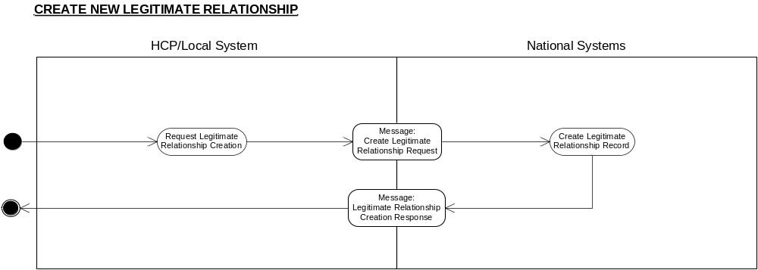

Business Transactions
- Create Legitimate Relationship Request
- Legitimate Relationship Creation Response

Create Legitimate Relationship Request

Purpose
The message is generated to notify the national system to establish a Legitimate Relationship record between the patient and the Workgroup, User Role Profile or other individual.

Business Communication Requirement

Communication Name | Create Legitimate Relationship Request
Sending Role | Request Legitimate Relationship Creation
Trigger Event | Legitimate Relationship creation required.
Communication Type | Request
Receiving Role | Create Legitimate Relationship Record

Business Communication Content

Level | Name  Item/Group | Definition | Example | Representation | Cardinality | Constraints & Dependencies | Default value | Null required | Outstanding issues
1 | Request Identifier | The unique identifier for the request message, generated by the system. |  | Format defined by Technical team:  UUID | 1
2 | Patient Identifier | The unique identifier for the patient involved in the Legitimate Relationship.  The identifier may be a temporary NHS Number, which would later be reconciled with the real NHS Number. | 1234567899 | NHS Number - Data Dictionary Standard  N10, including check digit calculated to Modulus 11 algorithm  OID 2.16.840.1.113883.2.1.4.1 | 1
3 | Start LRinvolved Group | Either a User Role Profile, Workgroup, or Other person is required. |  |  | 1..1 | This group contains one and only one of its possible subgroups
3.1 | Start Workgroup Details Subgroup |  |  |  | 0..1
3.1.1 | Workgroup Identifier | An identifier for a Workgroup. | 210987654321 | 12 character code - SDS representation | 1
 | End Workgroup Details Subgroup
3.2 | Start User details subgroup |  |  |  | 0..1 | NB if LR type is Colleague Granted or Self Claimed, choice of this group is mandatory as LR can only apply to an individual.
3.2.1 | User id | The SDS User identifier | 123456789012 | Twelve character UID as defined by the SDS group | 1 | If the LR type is self claimed, the User Id given here must be the same as the originating User Id in field 9.
3.2.2 | User Role Profile | The context in which the individual acts as part of the Legitimate Relationship. | 210987654321 | Twelve character UID as defined by the SDS group | 1
 | End User details subgroupd User details subgroup
3.33.3 | Start Other Person subgroupStart Other Person subgroup |  |  |  | 0..10..1
3.3.1 | Other Person NHS Number | The unique identifier for the Other Person involved in the Legitimate Relationship. | 1234567899 | NHS Number Data Dictionary standard  N10, including check digit calculated to Modulus 11 algorithm | 1
 | End Other Person subgroup
 | End LR Involved Group
4 | Frozen Legitimate Relationship Date and Time | Indicates that the Legitimate Relationship is to be created in the state “frozen” with a backdated freeze date. It specifies this backdated freeze date and time. |  | HL7 standard, accurate to ‘seconds’. | 0..1 | Must not be greater than the current date. | Null
5 | Legitimate Relationship Type | A pre-defined code indicating the type of Legitimate Relationship | 09 denotes  ‘Patient Self-Referral’ | Coded vocab  ’Subject Access Request’  Responding to Patient Complaint’  ‘Granted to colleague by User’  ‘Express consent’  ‘Court Order’  ‘Referral’  ‘Patient Registration’  Self Claimed Relationship’ Patient Self-referral’  ‘General Practice Registration’  ‘Other’ | 1 | Mandatory.  Where LR type is GRANT Author URP id and/or workgroups must be present.
6 | Legitimate Relationship Reason for Access | Where the Legitimate Relationship Type is “Self-claimed”, “colleague-granted” or “Expressed patient consent to access” a standard reason for the access must exist. | 01 denotes public interest | Coded vocab | 0..1 | See Legitimate Relationship Requirements Report for the list of standard values and which can be applied to the specific LR types.
7 | Legitimate Relationship Reason Text | A free-text element to record the reason for the Legitimate Relationship to exist. |  | No existing equivalent in the Data Dictionary. Format for similar free-text fields is AN255 | 0..1 | Free-text may be included for any Legitimate Relationship Reason Code.  Free text must be included where the Legitimate Relationship Reason For Access is  “OTHER”
8 | Alert Required | An indicator denoting that an Alert is required to be raised with the appropriate authority for administering Legitimate Relationships |  | True = Yes  False = Don’t know | 0..1 | In general, this flag will be set to null, leaving the NASP to interpret whether an alert is required based on the Legitimate Relationship Type. When set, the indicator will enable a particular LSP to deviate from the standard alert policy.
9 | Originator details group |  |  |  | 1..1
 | CHOICE OF
9.1 | Originating User Identifier | The unique identifier for the user requesting the creation of the Legitimate Relationship.  Required for audit and accountability purposes.  With the exception of Self Claimed relationships, the user generating the request to create the relationship may or may not be the same person as the user involved in the relationship. | 123456789012 | Twelve character UID as defined by the SDS group | 0..1 | Present whenever the creation of the LR is as a direct result of User action, for example when a Self Claimed or Colleague Granted relationship is being requested.  NB if LR type is Colleague Granted, then fields 9.2 and 9.3 must also be present.
9.2 | Originating User Role Profile | The unique identifier for the current Role Profile of the user requesting the creation of the Legitimate Relationship.  The user generating the request to create the relationship may or may not be the same person as the user involved in the relationship. | 210987654321 | Twelve character UID as defined by the SDS group | 0..1
9.3 | Originating user workgroups | List of workgroup codes found in originating user’s role profile, one per occurrence of this field | RMH00055 | SDS allocated | 0..n
 | OR
9.4 | Originating system id | The id of the system that generated the request for creation of LR  The definition of System-id for this purpose is: “An individual application running upon a server. Where there are multiple (n) applications running upon a single server, then there shall be considered to be n systems |  | SDS id | 0..1 | Present when the message is issued automatically by the application as a result of a business process.
 | End originator details group

Legitimate Relationship Creation Response

Purpose
The message is generated to inform the user requesting the creation of the Legitimate Relationship of the outcome of the request.

Business Communication Requirement

Communication Name | Legitimate Relationship Creation Response
Sending Role | Create Legitimate Relationship Record
Trigger Event | New Legitimate Relationship created on the relevant database or Legitimate Relationship creation activity failed
Communication Type | Response
Receiving Role | N/A

Business Communication Content

Level | Name  Item/Group | Definition | Example | Representation | Cardinality | Constraints & Dependencies | Default value | Null required | Outstanding issues
1 | Requesting Message Identifier | The identifier for the message requesting the creation of the Legitimate Relationship.  Required to link the Legitimate Relationship record with the respective creation message. |  | Format defined by Technical team  UUID | 1
2 | Legitimate Relationship Identifier | The unique identifier(s) of the Legitimate Relationship record created on the national system. | 12345 | OID 2.16.840.1.113883.2.1.3.2.4.18.3 | 0..1 | Will not be included if a Failure Reason Code value is present.
3 | Failure Reason Code | A code denoting the reason for failure to create a Legitimate Relationship on the national system. | 01 denotes  User Role Profile not found | User Role Profile not found  WorkGroup ID not found  NHS Number not found | 0..1 | Will not be included if a Legitimate Relationship Identifier value is present. If present, no LR will have been created. |  |  | Minimum code value set subject to change.

Note: Failure Reason Code has been modelled in a failure message

Legitimate Relationship Status Change

Description
Where an event takes place (e.g. a referral discharge) which affects the status of a Legitimate Relationship, a request is made (or generated) to update the Legitimate Relationship record to reflect the change in status. The request may be made by an individual user, or from an automated source (depending on business rules embedded in the system functionality). The status of the Legitimate Relationship will then be updated accordingly by the NASP. The status of the legitimate relationship may also be changed by the NASP as a result of time passing. Once the legitimate relationship expires, the relationship is removed so it cannot be referenced or modified further via this messaging interface (though it may be archived); it would then take no further part in access decisions or be available for query through the messages defined here.

Using the reasons for change of status (according to type of LR), NASP functionality will enable the appropriate change of status to take place.

Clinical Scenario
To be determined, pending design of the end-to-end business processes.

Activity diagram
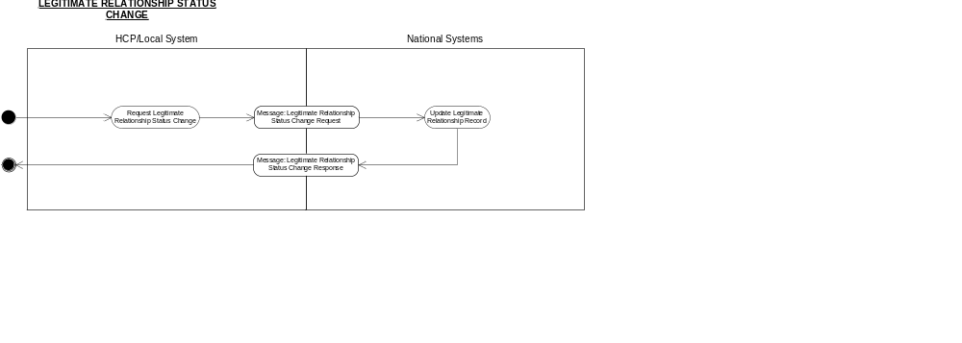

Business Transactions
- Legitimate Relationship Status Change Request
- Legitimate Relationship Status Change Response

Legitimate Relationship Status Change Request

Purpose
The message is generated to notify the national system to update the Legitimate Relationship record between a single patient and a nominated User Role Profile (NCRS User) or Workgroup or Other Person because an event has occurred that the affects the status of the relationship.

Business Communication Requirement

Communication Name | Legitimate Relationship Status Change Request
Sending Role | Request Legitimate Relationship Status Change
Trigger Event | Legitimate Relationship Status Change Required
Communication Type | Request
Receiving Role | Update Legitimate Relationship Record

Business Communication Content

Level | Name  Item/Group | Definition | Example | Representation | Cardinality | Constraints & Dependencies | Default value | Null required | Outstanding issues
1 | Request Identifier | The unique identifier for the message, generated by the system. |  | Format defined by Technical team  UUID | 1..1
2 | Patient Identifier | The unique identifier for the patient involved in the Legitimate Relationship.  The identifier may be a temporary NHS Number, which would later be reconciled with the real NHS Number. | 1234567899 | NHS Number - Data Dictionary Standard  N10, including check digit calculated to Modulus 11 algorithm | 1..1
3 | Legitimate Relationship Identifier | The unique identifier of a specific Legitimate Relationship record to have status changed. | 12345 | OID: 2.16.840.1.113883.2.1.3.2.4.18.3  (LR System) | 1..1 | Must be used to identify the specific Legitimate Relationship to have status changed context.
5 | Status Change Reason Code | A code indicating the reason for the change of status of the Legitimate Relationship. | 08 denotes Referral acceptance | Coded vocab | 1 | The following Reason Codes are no longer current:  “Referral cancellation”  “Workgroup closure”  “Patient is deceased”  “Timed out through lack of use”  “Further timed out”  The following Reason Codes are current:  “Relationship termination”  “Closure of case”  “Referral acceptance”  “Referral rejection”  “Referral abandonment”  “Referral Discharge”  “Patient Registration”  “Patient Deregistration”  “Self-referral cessation”  “Closure of SAR”. . |  |  | If a code is submitted that is no longer current, the message will be rejected. It will not change the status of the LR. Only the current codes should be used.  See table in Appendix D of the Legitimate Relationships Requirements Report to identify which of the current reason codes are valid for each LR Type
8 | Status Change Requester Details |  |  |  | 1..1
 | CHOICE OF
8.1 | Originating User Identifier | The unique identifier for the user requesting the change in status of the Legitimate Relationship.  Required for audit and accountability purposes.  The user generating the request to change the status of the relationship may or may not be the same person as the user involved in the relationship. | 123456789012 | Twelve character UID as defined by the SDS group | 0..1 | Present whenever the change in status of the LR is as a direct result of User action.
8.2 | Originating User Role Profile | The unique identifier for the current Role Profile of the user requesting the change in status of the Legitimate Relationship.  The user generating the request to change the status of the relationship may or may not be the same person as the user involved in the relationship. | 210987654321 | Twelve character UID as defined by the SDS group | 0..1 | Used when the application creating the message wishes to defer to the recipient (the Legitimate Relationship Service) the access control decision on whether the status change is to be authorised. |  |  | This field is not expected to be present in normal use of this message.
 | OR
8.3 | Originating system id | The id of the system that generated the request for status change of LR  The definition of System-Id for this purpose is: “An individual application running upon a server. Where there are multiple (n) applications running upon a single server, then there shall be considered to be n systems”. |  | SDS id | 0..1 | Present when the message is issued automatically by the application as a result of a business process.

Legitimate Relationship Status Change Response

Purpose
The message is generated to inform the user requesting the change in status of the Legitimate Relationship of the outcome of the request.

Business Communication Requirement

Communication Name | Legitimate Relationship Status Change Response
Sending Role | Update Legitimate Relationship Record
Trigger Event | Legitimate Relationship record updated to reflect change of status
Communication Type | Response
Receiving Role | N/A

Business Communication Content

Level | Name  Item/Group | Definition | Example | Representation | Cardinality | Constraints & Dependencies | Default value | Null required | Outstanding issues
1 | Requesting Message Identifier | The identifier for the message requesting the change in status of the Legitimate Relationship.  Required to link the response with the status change message it is responding to. |  | Format defined by Technical team  UUID format | 1
2 | Legitimate Relationship Identifier | The unique identifier of the Legitimate Relationship(s) whose status has changed | 12345 | OID: 2.16.840.1.113883.2.1.3.2.4.18.3  (LR System) | 1..1 | Contains only one value where the Legitimate Relationship Status Change Request identified a specific LR Record  The message will contain either one or more Legitimate Relationship Identifiers or a Failure Reason Code, but not both.
3 | Failure Reason Code | A code denoting the reason for failure to change the status of the Legitimate Relationships identified in the Legitimate Relationship Status Change Request message. | 01 denotes User Role Profile not found | User Role Profile not found  WorkGroup ID not found  NHS Number not found  No LR found with a status compatible with this status change request (returned when no specific LR id was nominated in the change request), or the LR with the nominated LR ID has a status and type incompatible with this status change request. | 0..1 | Will not be included if one or more Legitimate Relationship Identifier values are present.  The message will contain either one or more Legitimate Relationship Identifiers or a Failure Reason Code, but not both. |  |  | Minimum code value set subject to change.  The single code so far specified for the incom-patibility failures may be split into a number of more specific codes.
Note : Failure Reason Code modelled in a separate message.

Legitimate Relationship Confirmation Request

Description
Confirmation Requests on Legitimate Relationships are intended to determine whether or not a relationship exists between a patient and an individual User Role Profile (NCRS User) or Other Person. The user (or local system) or application requests the confirmation, including whether a ‘short’ or ‘history’ response is required. The national system obtains the relevant details from the Legitimate Relationship database, and returns an appropriate response to the user (or local system). It is expected that this activity will occur frequently, as a pre-cursor to subsequent action concerning Legitimate Relationship record management or patient record access activities.

Clinical Scenario
To be determined, pending design of the end-to-end business processes.

Activity diagram
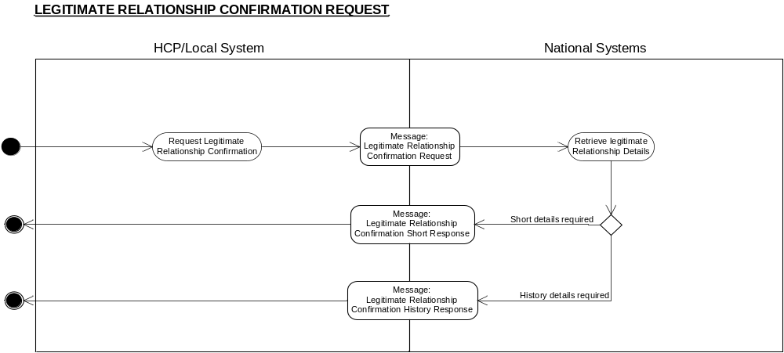

Business Transactions
- Legitimate Relationship Confirmation Request
- Legitimate Relationship Confirmation Short Response
- Legitimate Relationship Confirmation History Response

Legitimate Relationship Confirmation Request

Purpose
The message is to request the relevant national system to ascertain whether or not a Legitimate Relationship between an entity (User acting in a particular Role Profile or other person) and a single patient exists in an “active” state, or has existed but is now in an historic state of either “inactive’”, “partial” or “frozen”.

Business Communication Requirement

Communication Name | Legitimate Relationship Confirmation Request
Sending Role | Request Legitimate Relationship Confirmation
Trigger Event | Confirmation of the existence of Legitimate Relationship is required
Communication Type | Request
Receiving Role | Retrieve Legitimate Relationship Details

Business Communication Content

Level | Name  Item/Group | Definition | Example | Representation | Cardinality | Constraints & Dependencies | Default value | Null required | Outstanding issues
1 | Request Identifier | The unique identifier for the request message, generated by the system. |  | Format defined by Technical team  UUID format | 1
2 | Patient Identifier | The unique identifier for the patient whose involvement in an LR with the identified User or Other Person is being confirmed. | 1234567899 | NHS Number - Data Dictionary Standard  N10, including check digit calculated to Modulus 11 algorithm | 1..1
3 | Start User group |  |  |  | 0..1 | The query is either in relation to a User or to a person with an NHS number, but not both.
3.1 | User Id | The Id of the User for whom the relationship is being confirmed | 123456789012 | Twelve character UID as defined by the SDS group | 1
3.2 | User Role Profile | The Role Profile for which the User whose relationship with the patient is being confirmed. | 210987654321 | Twelve character UID as defined by the SDS group | 1
3.3 | Work group code | List of workgroup codes found in user’s current role profile, one per occurrence of this field | RMH00055 | SDS allocated | 0..n
 | End User Group
44 | Start Other Person groupt |  |  |  | 0..1
4.1 | Other Person NHS Number | The unique identifier for the Other Person possibly involved in a Legitimate Relationship with the patient. | 1234567899 | NHS Number Data Dictionary standard  N10, including check digit calculated to Modulus 11 algorithm | 0..1
 | End Other Person Group
5 | Required Enquiry Response Type | A code to indicate the type of response required.  Required to prevent unnecessary and expensive computational searches of historic data. | Short | 5 character alphanumeric | 1 | ‘Short’;  or ‘Hist ”. Where “Short” is entered, only “active” relationships will be identified. Where “Hist” is entered, the best available LR is returned. The order of priority is “active”, “inactive”, “partial” “frozen”. | ‘Short’
6 | Start originating requester information Group |  |  |  | 0..1 |  |  |  | It is not expected that this subgroup will be in normal use of the message.
 | CHOICE OF
6.1 | Originating User Identifier | The unique identifier for the user requesting the confirmation.  Required for audit and accountability purposes.  The User generating the confirmation request may or may not be the same person as the User involved in the relationship. | 123456789012 | Twelve character UID as defined by the SDS group | 1
6.2 | Originating User Role Profile | The unique identifier for the current Role Profile of the user requesting the confirmation.  The user generating the request for confirmation may or may not be the same person as the user involved in the relationship. | 210987654321 | Twelve character UID as defined by the SDS group | 0..1 | Used when the application creating the message wishes to defer to the recipient (the Legitimate Relationship Service) the access control decision on whether the confirmation is to be authorised. Not used when the confirmation query is system initiated
 | OR
6.3 | Originating system id | The id of the system that generated the query.  The definition of System-ID for this purpose is: “An individual application running upon a server. Where there are multiple (n) applications running upon a single server, then there shall be considered to be n systems”. |  | SDS id | 1..2 | Present when the message is issued automatically by the application as a result of a business process.
 | End originating requesters information group

Legitimate Relationship Confirmation Short Response

Purpose
The message contains details which indicate the existence (or otherwise) of a current (active) Legitimate Relationship between a patient and a User or other person.

Business Communication Requirement

Communication Name | Legitimate Relationship Confirmation Short Response
Sending Role | Retrieve Legitimate Relationship Details
Trigger Event | Legitimate Relationship Confirmation Request received
Communication Type | Response
Receiving Role | N/A

Business Communication Content

Level | Name  Item/Group | Definition | Example | Representation | Cardinality | Constraints & Dependencies | Default value | Null required | Outstanding issues
1 | Originating Request Identifier | The unique identifier for the originating request message.  Required to link the Request with the Response. |  | Format defined by Technical team  UUID Format | 1
2 | Start Response Subgroup | Response or failure for the patient for which a confirmation request was made |  |  | 1
2.1 | Active Legitimate Relationship Existence Indicator | A value stating the existence or absence of an active Legitimate Relationship record | “Yes” | Boolean | 0..1 | “Yes”; “No”  Either this Boolean appears or a failure reason code appears but not both.
2.2 | Failure Reason Code | A code indicating a failure to locate a legitimate relationship record due to inaccuracy of requesting data or other system problem. | 01 denotes User Role Profile not found | Patient not found.  User Id Not Found.  User Role Profile not found  Other User NHS Number not found | 0..1 | Will only be included where a failure to locate a Legitimate Relationship record is due to an inability to locate a Legitimate Relationship party specified in the request, and thus no Boolean value can be offered. |  |  | Minimum code value set may be subject to change.
 | End Response Group
Note : Failure Reason Code modelled in a separate message.

Legitimate Relationship Confirmation History Response

Purpose
The message contains details which indicate the existence (or otherwise) of a Legitimate Relationship between a patient and a User or other person, and the status of the legitimate relationship found, The status of legitimate relationship will be either “active”, “inactive” “partial” or “frozen”. If multiple legitimate relationships exist, only one will be returned: the order of priority will be “active”, “inactive”, “partial”, “frozen”. Where the status returned is not “active”, the date and time at which the current status was established is provided.

Business Communication Requirement

Communication Name | Legitimate Relationship Confirmation History Response
Sending Role | Retrieve Legitimate Relationship Details
Trigger Event | Legitimate Relationship Confirmation Request received.
Communication Type | Response
Receiving Role | N/A

Business Communication Content

Level | Name  Item/Group | Definition | Example | Representation | Cardinality | Constraints & Dependencies | Default value | Null required | Outstanding issues
1 | Originating Request Identifier | The unique identifier for the originating request message.  Required to link the Request with the Response. |  | Format defined by Technical team  UUID Format | 1
2 | Start Response Subgroup | Response or failure. |  |  | 1
2.1 | Active Legitimate Relationship Existence Indicator | A value stating the existence or absence of an active Legitimate Relationship record | “Yes” | Boolean | 0..1 | “Yes”; “No”  Either this Boolean appears or a failure reason code appears but not both.
2.2 | Historic Legitimate Relationship Date and Time | The date and time at which the latest historic Legitimate Relationship valid for the whole User Role Profile or other user specified in the request was established in its current state. | 20041231235959 | HL7 standard, accurate to ‘seconds’ | 0..1 | Not present if the LR found is “active”.
2.3 | Legitimate Relationship Status Code | A code for the status of legitimate relationship found. | 02 denotes “inactive” | Coded vocab | 0..1 | Values:  01 “active”, 02“inactive”, 03“partial” 04“frozen”. A null will be returned if the Active Legitimate Relationship Existence Indicator is “No”.
2.4 | Failure Reason Code | A code indicating a failure to locate a legitimate relationship record due to inaccuracy of requesting data or other system problem. | 01 denotes User Role Profile not found | Patient not found.  User Id Not Found.  User Role Profile not found  Other User NHS Number not found | 0..1 | Will only be included where a failure to locate a Legitimate Relationship record is due to an inability to locate a Legitimate Relationship party specified in the request, and thus no Boolean value can be offered. |  |  | Minimum code value set may be subject to change.
 | End Response Group
Note : Failure Reason Code modelled in a separate message.

Legitimate Relationship Batch Confirmation Request

Description
Batch Confirmation Requests on Legitimate Relationships are intended to determine whether or not an active Legitimate Relationship exists between a list of patients and an individual User Role Profile (NCRS User) or Other Person. The user (or local system) or application requests the confirmation. With batch requests no historic response is available. The national system obtains the relevant details from the Legitimate Relationship database, and returns an appropriate response to the user (or local system). It is expected that batch requests will occur as a pre-cursor to subsequent action concerning accesses to patient lists in a variety of business contexts.

Clinical Scenario
To be determined, pending design of the end-to-end business processes.

Activity diagram

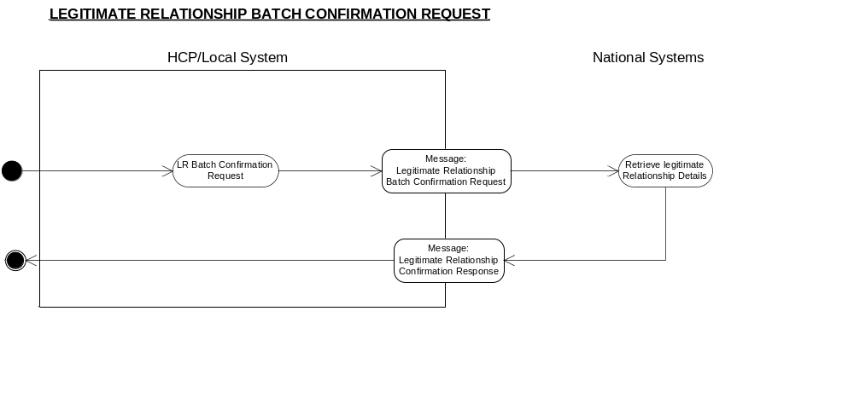

Business Transactions
- Legitimate Relationship Batch Confirmation Request
- Legitimate Relationship Batch Confirmation Response

Legitimate Relationship Batch Confirmation Request

Purpose
The message is to request the relevant national system to ascertain whether or not an active Legitimate Relationship between an entity (User acting in a particular Role Profile or other person) and a list of patient exists.

Business Communication Requirement

Communication Name | Legitimate Relationship Batch Confirmation Request
Sending Role | Request Legitimate Relationship Confirmation
Trigger Event | Confirmation of the existence of more than one Legitimate Relationship is required
Communication Type | Request
Receiving Role | Retrieve Legitimate Relationship Details

Business Communication Content

Level |  | Name  Item/Group | Definition | Example | Representation | Cardinality | Constraints & Dependencies |  | Default value | Null required | Outstanding issues
1 |  | Request Identifier | The unique identifier for the request message, generated by the system. |  | Format defined by Technical team  UUID format | 1
2 |  | Patient Identifiers | The unique identifiers for the patient whose involvement in an LR with the identified User or Other Person is being confirmed. | 1234567899 | NHS Number - Data Dictionary Standard  N10, including check digit calculated to Modulus 11 algorithm | 2..500 |  |  |  |  | An upper limit of 500 NHS Numbers is given, but this is subject to confirmation.
3 |  | Start User group |  |  |  | 0..1 | The query is either in relation to a User or to a person with an NHS number, but not both.
3.1 |  | User Id | The Id of the User for whom the relationship is being confirmed | 123456789012 | Twelve character UID as defined by the SDS group | 1
3.2 |  | User Role Profile | The Role Profile for which the User whose relationship with the patient is being confirmed. | 210987654321 | Twelve character UID as defined by the SDS group | 1
3.3 |  | Work group codes | List of workgroup codes found in user’s current role profile, one per occurrence of this field | RMH00055 | SDS allocated | 0..n
 |  | End User groupd
44 |  | Start Other Person groupStart
4.1 |  | Other Person NHS Number | The unique identifier for the Other Person possibly involved in a Legitimate Relationship with the patient. | 1234567899 | NHS Number Data Dictionary standard  N10, including check digit calculated to Modulus 11 algorithm | 0..1
 |  | End Other Person Group
6 |  | Start originating requester information Group |  |  |  | 0..1
 |  | CHOICE OF
6.1 |  | Originating User Identifier | The unique identifier for the user requesting the confirmation.  Required for audit and accountability purposes.  The User generating the confirmation request may or may not be the same person as the User involved in the relationship. | 123456789012 | Twelve character UID as defined by the SDS group | 1
6.2 |  | Originating User Role Profile | The unique identifier for the current Role Profile of the user requesting the confirmation.  The user generating the request for confirmation may or may not be the same person as the user involved in the relationship. | 210987654321 | Twelve character UID as defined by the SDS group | 0..1 | Used when the application creating the message wishes to defer to the recipient (the Legitimate Relationship Service) the access control decision on whether the confirmation is to be authorised. Not used when the confirmation query is system initiated |  |  |  | Additional guidance required on this from IG. Currently not expected that this field will be used.
 |  | OR
6.3 |  | Originating system id | The id of the system that initiated the query  The definition of System-Id for this purpose is: “An individual application running upon a server. Where there are multiple (n) applications running upon a single server, then there shall be considered to be n systems.” |  | SDS id | 1..1 | Present when the message is issued automatically by the application as a result of a business process.  The system id MUST be present if the originator is a system.
 |  | End originating requester information Group

Legitimate Relationship Batch Confirmation Response

Purpose
The message contains details which indicates, for each patient in the request, the existence (or otherwise) of a current (active) Legitimate Relationship between that patient and a User or other person.

Business Communication Requirement

Communication Name | Legitimate Relationship Batch Confirmation Response
Sending Role | Retrieve Legitimate Relationship Details
Trigger Event | Legitimate Relationship Batch Confirmation Request received
Communication Type | Response
Receiving Role | N/A

1 | Originating Request Identifier | The unique identifier for the originating request message.  Required to link the Request with the Response. |  | Format defined by Technical team  UUID Format | 1
2 | Start Response Subgroup | Response or failure for each patient for which a confirmation request was made |  |  | 0..* | Not present only if an overall failure has occurred (see field 3). Values in the group are repeated of the same number and in the same sequence as the patients are listed in the request.
2.1 | Patient Identifier | The unique identifier for the patient whose involvement in an LR with the identified User or Other Person is being confirmed. | 1234567899 | NHS Number – Data Dictionary Standard  N10, including check digit calculated to Modulus 11 algorithm | 1
2.2 | Active Legitimate Relationship Existence Indicator | A value stating the existence or absence of an active Legitimate Relationship record | “Yes” | Boolean | 0..1 | “Yes”; “No”  Either this Boolean appears or a failure reason code appears but not both.  The Boolean must be paired with the NHS number of the patient to whom the request applied.
2.3 | Failure Reason Code | A code indicating a failure to locate a legitimate relationship record due to inaccuracy of requesting data or other system problem. | 01 denotes Patient not found | Patient not found. | 0..1 | Will only be included in relation to a particular patient where a failure to locate a Legitimate Relationship record is due to an inability to locate a Legitimate Relationship party specified in the request, and thus no Boolean value can be offered. |  |  | Minimum code value set may be subject to change.
 | End Response Group
3 | Overall Failure Reason Code | A code indicating an overall failure to provide the requested responses due to inaccuracy of requesting data or other system problem. |  | User Id Not Found.  User Role Profile not found  Other User NHS Number not found | 0..1 | Either this field or the Response Subgroup field will be present  Any fail that affects every individual response will be at this higher level.

Obtain Legitimate Relationship Details

Description

The process identifies the Legitimate Relationships that exist between a patient and an individual User (NCRS User), Workgroup or Other Person and retrieves the pertinent details from the database record. The user (or local system) or application submits the request, including whether a ‘simple’ or ‘complete’ response is required. The NASP service obtains the relevant details, and returns an appropriate response to the user (or local system).

This message will be generally used in response to administrative actions required against the Legitimate Relationship record, for management purposes. As this message can return an LR id code, it can be used when there is a requirement to update an LR and the LR id is not persisted on the local system.

Clinical Scenario
To be determined, pending design of the end-to-end business processes.

Activity diagram
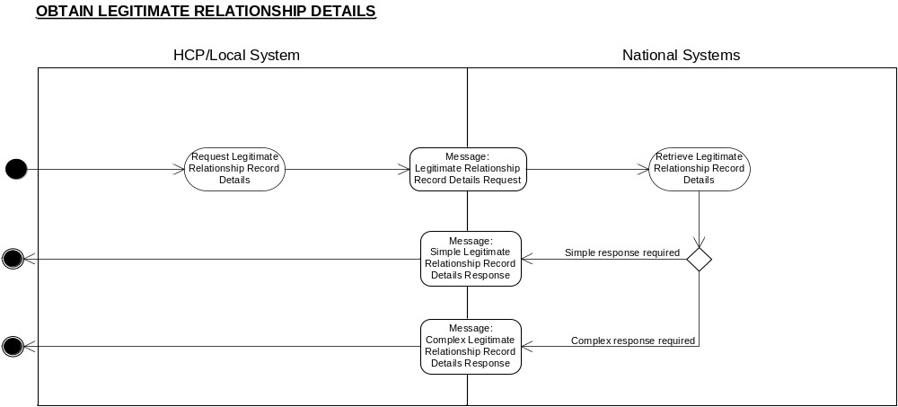

Business Transactions
- Legitimate Relationship Record Details Request
- Simple Legitimate Relationship Record Details Response
- Complete Legitimate Relationship Record Details Response

Legitimate Relationship Record Details Request

Purpose
The message notifies the national system of a request to retrieve and return the contents of all relevant Legitimate Relationship records held for the patient , in order to determine which individuals or workgroups are or were involved in a Legitimate Relationship with the specified patient for a (optional) specified time period. There is a capability to specify the amount of information returned.

Business Communication Requirement

Communication Name | Legitimate Relationship Record Details Request
Sending Role | Legitimate Relationship Record Details
Trigger Event | Legitimate Relationship Record details required
Communication Type | Request
Receiving Role | Retrieve Legitimate Relationship Record Details

Business Communication Content

 | Level | Name  Item/Group | Definition | Example | Representation | Cardinality | Constraints & Dependencies | Default value | Null required | Outstanding issues
 | 1 | Request Identifier | The unique identifier for the request, generated by the system. |  | Format defined by Technical team | 1
 | 2 | Patient Identifier | The unique identifier for the patient involved in the Legitimate Relationship. | 1234567899 | NHS Number - Data Dictionary Standard  N10, including check digit calculated to Modulus 11 algorithm | 1
 | 3 | Required Enquiry Response Type | A code to indicate the type of response required | “Comp” | Coded vocab  01 Simple  02 Comprehensive | 1 | ‘A ‘simple’ query requires minimal information to be in the response, i.e. for each relationship detected, the users/ workgroups involved in the relationship, and any historic LR date within the time period specified that has been set for the relationship.
 | 4 | Time Period | The period of time to which the query pertains. | 01/01/2003  to 01/01/2004  HHMMSS | Date/Time Interval. | 0..1 | If no Time Period is specified, only current active relationships will be returned in the response.  Cannot have a high sub-element without a low but a low sub-element can exist without a high sub-element. | No default for Start Date.  Default for ‘End Date’ (or equivalent) is Current Date
 | 5 | Originating User Identifier | The unique identifier for the user requesting the Legitimate Relationship details.  Required for audit and accountability purposes. | 123456789012 | Twelve character UID as defined by the SDS group | 1
6 |  | Override Dissent Flag | Boolean Flag through which the caller requests that patient dissent should be overridden. |  | Boolean | 1..1 | Values:  1 = Override  0 = No override  Omitting this field is the equivalent of setting its value to 0.  Must only be set to 1 if the user has been warned that the patient has dissented and has confirmed that despite this they wish to override dissent.
7 |  | Override Dissent Reason Code | A code indicating the reason for the override, provided for insertion in the alert that must be raised by the NASP as a consequence of overriding dissent. |  |  | 1..1 | Values are:  00 = No override  01 = Public Interest  02 = Required by Statute  03 = Court Order  04 = Best interest of patient who lacks mental capacity to give consent  05 = Best interest of non-competent child when parent or guardian has refused consent & insufficient time to obtain court order.
8 |  | Override Dissent Reason Text | Further explanation of the reason for override, provided for insertion in the alert that must be raised by the NASP as a consequence of overriding dissent. |  | No existing equivalent in the Data Dictionary. Format for similar free-text fields is AN255 | 0..1 | Free text present when available. (ie whenever entered by the user).
 | 9 | Originating User Role Profile | The unique identifier for the current Role Profile of the user making the request. | 210987654321 | Twelve character UID as defined by the SDS group | 0..1 | Used when the application creating the message wishes to defer to the recipient (the Legitimate Relationship Service) the access control decision on whether the request is to be authorised, or whenever dissent override is requested.

Simple Legitimate Relationship Record Details Response

Purpose
The message contains basic details for Legitimate Relationship records held satisfying the criteria laid down in the originating request, showing the individuals and/or workgroups involved in Legitimate Relationships with the specified patient.

Business Communication Requirement

Communication Name | Simple Legitimate Relationship Record Details Response
Sending Role | Retrieve Legitimate Relationship Record Details
Trigger Event | Legitimate Relationship Record Details Request received
Communication Type | Response
Receiving Role | N/A

Business Communication Content

Level | Name  Item/Group | Definition | Example | Representation | Cardinality | Constraints & Dependencies | Default value | Null required | Outstanding issues
1 | Originating Request Identifier | The unique identifier for the originating request message.  Required to link the Request with the Response. |  | Format defined by Technical team  UUID Format | 1
2 | Patient Identifier | The unique identifier for the patient involved in the Legitimate Relationship(s). | 1234567899 | NHS Number - Data Dictionary Standard  N10, including check digit calculated to Modulus 11 algorithm | 1
3 | Start Legitimate Relationships Details Group |  |  |  | 0..* | A cardinality of zero is possible because there may be no LRs satisfying the request criteria or there may have been a failure.
3.1 | Legitimate Relationship Identifier | The unique identifier of the Legitimate Relationship record created on the national system. | 12345 | OID: 2.16.840.1.113883.2.1.3.2.4.18.3
3.2 | Start Legitimate Relationship Parties sub-group |  |  |  | 1 | This group will contain either a User Identifier, Workgroup Details or Other Person Subgroup.
3.2.1 | Start Workgroup Details Subgroup |  |  |  | 0..1 | Each entry is either a Work group Identifier, a User/Profile identifier or an Other Person Identifier
3.2.1.1 | Workgroup Identifier | An identifier for a Workgroup. | RMH00055 | SDS allocated | 1
 | End Workgroup Details Subgroup
3.2.2 | Start User Details Subgroup |  |  |  | 0..1 | Each entry is either a Work group Identifier, a User identifier with User Role Profile or an Other Person Identifier
3.2.2.1 | User Identifier | The unique identifier for a User (e.g. the Health Care Professional, Administrator, Technician, etc.) involved in the Legitimate Relationship. | 123456789012 | Twelve character UID as defined by the SDS group | 1
3.2.2.2 | User Role Profile | The context in which the individual acts as part of the Legitimate Relationship. | 210987654321 | Twelve character UID as defined by the SDS group | 1 | User Identifier must exist
 | End User Details Subgroup
3.2.3 | Start Other Person details subgroup |  |  |  | 0..1 | Each entry is either a Work group Identifier, a User/Profile identifier or an Other Person Identifier
3.2.3.1 | Other Person NHS Number | The unique identifier for the Other Person involved in the Legitimate Relationship. | 1234567899 | NHS Number Data Dictionary standard  N10, including check digit calculated to Modulus 11 algorithm | 1
 | End other Person details subgroup
 | End Legitimate Relationship Parties Sub-group
3.3 | Historic Legitimate Relationship Date and Time | The date and time at which the Legitimate Relationship was set to its current status. | 20041231235959 | HL7 standard, accurate to ‘seconds’ | 0..1 | This date is present unless the legitimate relationship is "active". Note that expired relationships are not returned at all
3.4 | Legitimate Relationship Status Code | A code for the status of legitimate relationship found. | 02 denotes “inactive” | Coded vocab | 0..1 | Values:  01 “active”, 02“inactive”, 03“partial” 04“frozen”. A null will be returned if the Active Legitimate Relationship Existence Indicator is “No”.
 | End Legitimate Relationship Details Group
4 | Failure Reason Code | A code denoting the reason for failure to perform the requested action. | 01 denotes  User Role Profile not found | Patient not found  Originating User Role Profile not found | 0..1 | Will not be included if a Legitimate Relationships Subgroup value is present.  The message will contain either one or more Legitimate Relationships subgroups or a Failure Reason Code, but not both. |  |  | Minimum code value set may be subject to change.
Note: Failure Reason Code modelled in a separate message.

Complete Legitimate Relationship Record Details Response

Purpose
The message contains the full details for Legitimate Relationship records held on the database satisfying the criteria laid down in the originating request, showing the individuals or workgroups involved in Legitimate Relationships with the specified patient.

Business Communication Requirement

Communication Name | Complete Legitimate Relationship Record Details Response
Sending Role | Retrieve Legitimate Relationship Record Details
Trigger Event | Legitimate Relationship Record Details Request received
Communication Type | Response
Receiving Role | N/A

Business Communication Content

Level | Name  Item/Group | Definition | Example | Representation | Cardinality | Constraints & Dependencies |  | Default value | Null required | Outstanding issues
1 | Originating Request Identifier | The unique identifier for the originating request message.  Required to link the Request with the Response. |  | Format defined by Technical team  UUID Format | 1
2 | Patient Identifier | The unique identifier for the patient involved in the Legitimate Relationship(s). | 1234567899 | NHS Number - Data Dictionary Standard  N10, including check digit calculated to Modulus 11 algorithm | 1
3 | Start Legitimate Relationship Details Group |  |  |  | 0..* | A cardinality of zero is possible because there may be no LRs satisfying the request criteria or there may have been a failure.
3.1 | Legitimate Relationship Identifier | The unique identifier of the Legitimate Relationship record created on the national system. | 12345 | OID: 2.16.840.1.113883.2.1.3.2.4.18.3  (LR System) | 1
3.2 | Start Legitimate Relationship Parties Sub-group |  |  |  | 1 | Each entry is either a Work group Identifier, a User/Profile identifier or an Other Person Identifier
3.2.1 | Start Workgroup Details Subgroup |  |  |  | 0..1 | This group will contain either a User Identifier, Workgroup Details or Other Person Subgroup.
3.2.1.2 | Workgroup Identifier | An identifier for a Workgroup. | RMH00055 | SDS allocated | 1
 | End Workgroup Details Subgroup
3.2.2 | Start user details subgroup |  |  |  | 0..1 | Each entry is either a Work group Identifier, a User identifier with User Role Profile or an Other Person Identifier
3.2.2.1 | User Identifier | The unique identifier for a User (e.g. the Health Care Professional, Administrator, Technician, etc.) involved in the Legitimate Relationship. | 123456789012 | Twelve character UID as defined by the SDS group | 1 | The message will contain either a User Identifier, a Workgroup Details or Other Person Subgroup, but not all three.
3.2.2.2 | User Role Profile | The context in which the individual acts as part of the Legitimate Relationship. | 210987654321 | Twelve character UID as defined by the SDS group | 1
 | End user details subgroup
3.2.3 | Start Other person details subgroup |  |  |  | 0..1 | Each entry is either a Work group Identifier, a User identifier with User Role Profile or an Other Person Identifier
3.2.3.1 | Other Person NHS Number | The unique identifier for the Other Person involved in the Legitimate Relationship. | 1234567899 | NHS Number Data Dictionary standard  N10, including check digit calculated to Modulus 11 algorithm | 1
 | End Other Person details subgroup
 | End Legitimate Relationship Parties Sub-group
3.3 | Legitimate Relationship Start Date and Time | The date and time from which the Legitimate Relationship is active. | 20041231235959 | HL7 standard, accurate to ‘seconds’ | 1
3.4 | Historic Legitimate Relationship Date and Time | The date and time at which the Legitimate Relationship was set to its current status. | 20041231235959 | HL7 standard, accurate to ‘seconds’ | 0..1 | This date is present unless the legitimate relationship is "active". Note that expired relationships are not returned at all
3.5 | Legitimate Relationship Status Code | A code for the status of legitimate relationship found. | 02 denotes “inactive” | Coded vocab | 0..1 | Values:  01 “active”, 02“inactive”, 03“partial” 04“frozen”. A null will be returned if the Active Legitimate Relationship Existence Indicator is “No”.
3.6 | Legitimate Relationship Type | A pre-defined code indicating the type of Legitimate Relationship. | 01 denotes Subject Access Request | Coded vocab  ’Subject Access Request’  Responding to Patient Complaint’  ‘Granted to colleague by User’  ‘Express consent’  ‘Court Order’  ‘Referral’  ‘Patient Registration’  Self Claimed Relationship’ Patient Self-referral’  ‘General Practice Registration’  ‘Other’ | 1..1 | Minimum value set:
3.7 | Legitimate Relationship Reason for Access | Where the Legitimate Relationship Type is “self-claimed”, “colleague-granted” or “expressed patient consent to access”, a standard reason for the access must exist. | 01 denotes public interest. | Coded vocab | 0..1 | See Legitimate Relationship Requirements Report for the list of standard values and which can be applied to the specific LR types.
3.8 | Legitimate Relationship Reason Text | A free-text element to record the reason for the Legitimate Relationship to exist. |  | No existing equivalent in the Data Dictionary. Format for similar free-text fields is AN255 | 0..1 | Free-text may be present for any Legitimate Relationship Reason Code  This field will be present if Reason for Access is OTHER.
 | Start LR Creator group
 | CHOICE OF
3.9 | Legitimate Relationship Creator Identifier | The unique identifier for the user requesting the creation of the Legitimate Relationship. | 987654321 | OID: 2.16.840.1.113883.2.1.3.2.4.11  (NHS Directory Services) | 0..1 | Will not always be present – creator may not always be known.
3.10 | Legitimate Relationship Creator Role Profile | The context in which the creator of the Legitimate Relationship was acting when requesting the creation of the relationship | 31234 |  | 0..1 | May not always be known.  The Creator Identifier must also be present if this field is present.
 | OR
3.11 | LR Creator system id | The id of the system that created the LR  The definition of System-id for this purpose is: “An individual application running upon a server. Where there are multiple (n) applications running upon a single server, then there shall be considered to be n systems |  | SDS id | 0..1 | This will be present to indicate those LRs which were not user generated.
 | End LR Creator group
3.12 | Last status change reason code received | The reason code that was specified in the last LR Status Change Request Message received for this Legitimate Relationship. | 08 denotes Referral acceptance | Coded vocab list | 0..1 | The following Reason Codes are no longer current:  “Referral cancellation”  “Workgroup closure”  “Patient is deceased”  “Timed out through lack of use”  “Further timed out”  The following Reason Codes are current:  “Relationship termination”  “Closure of case”  “Referral acceptance”  “Referral rejection”  “Referral abandonment”  “Referral Discharge”  “Patient Registration”  “Patient Deregistration”  “Self-referral cessation”  “Closure of SAR”. . |  |  |  | See table in Legitimate Relationships Requirements Report to identify which reason code is valid for each LR Type
3.13 | Legitimate Relationship Status Changer Identifier | The unique identifier for the user issuing the last LR Status Change Request Message for the Legitimate Relationship. |  | UID or UUID | 0..1 | Will not always be present, since none may have been received.
3.14 | Legitimate Relationship Status Changer Role Profile | The role profile in which the user was acting when requesting the change to the status of the relationship | 31234 | OID: 2.16.840.1.113883.2.1.3.2.4.11  (NHS Directory Services) | 0..1 | Will not always be present, since no request may have been received.  The Legitimate Relationship Status Changer Identifier must also be present if this field is present.
 | End Legitimate Relationship Details Group
4 | Failure Reason Code | A code denoting the reason for failure to perform the requested action. | 01 denotes  User Role Profile not found | Patient not found  Originating User Role Profile not found | 0..1 | Will not be included if a Legitimate Relationship Parties Subgroup value is present.  The message will contain either one or more Legitimate Relationship Parties subgroups or a Failure Reason Code, but not both. |  |  |  | Minimum code value set may be subject to change.
Note : Failure Reason Code modelled in a separate message.

Workgroup Membership Management: Please note that these messages will not be in MiM until September 2005.
The following messages are identified for automating Workgroup membership management.

Identify User Role Profiles

Description
Requests the Org Code and Job Role of each of the identified user’s User Role Profiles (URPs). The request may specify selection criteria that cause only a subset of the total set of URPs belonging to the user to be requested.

Clinical Scenario
When a Workgroup Membership Administrator (WGMA) wishes to add a user to a workgroup, the WGMA needs to know which URP(s) to add the user under. This business process allows the application being used by the WGMA to obtain and present to the WGMA the options available.

Activity diagram
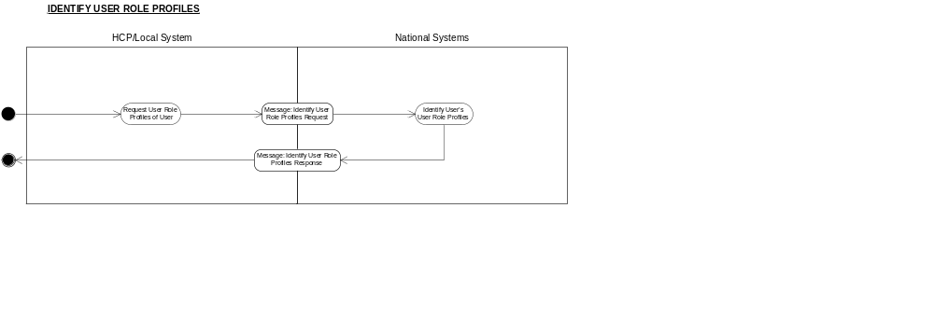

Business Transactions

Identify User Role Profiles Request

Purpose
See Description and Clinical Scenario.

Business Communication Requirement

Communication Name | Identify User Role Profiles Request
Sending Role | Request for URPs
Trigger Event | A User acting in a URP needs to be joined to a Workgroup
Communication Type | Request
Receiving Role | Return the requested URP information

Business Communication Content

Level | Name  Item/Group | Definition | Example | Representation | Cardinality | Constraints & Dependencies | Default value | Null required | Outstanding issues
1 | Request Identifier | The unique identifier for the request message, generated by the system. |  | Format defined by Technical team:  UUID | 1
2 | User id | The SDS User identifier of the User whose URPs are being requested | 123456789012 | Twelve character UID as defined by the SDS group | 1
3 | Start URP Selection Group | Either a URP Identifier or selection criteria for the URP |  |  | 1
3.1 | User Role Profile Id | If the identity of the URP is known it can be specified here to define the required URP uniquely | 210987654321 | Twelve character UID as defined by the SDS group | 0..1 | If present, none of the other fields in this Selection Group is present.
3.2 | Organisation Code | If specified, causes only URPs with this Organisation Code to be returned | 1.2.826.0.1285.0.1.10 | SDS oid | 0..1 | Not present if the URP Id field is present
3.3 | Job Role | If Specified, causes only URPs with this Job Role tertiary value to be returned | R0570 | The tertiary Job Role code of the Job Role ( a five character value consisting of one alpha character and four numeric) | 0..1 | Not present if the URP Id field is present
 | End URP Selection Group
4 | Originating User Identifier | The unique identifier for the sending application’s logged on user at the time the request was made.  Required for audit and accountability purposes. | 123456789012 | Twelve character UID as defined by the SDS group | 1
5 | Originating system id | The id of the system that generated the request  Used for audit purposes. |  | SDS id | 1

Identify User Role Profiles Response

Purpose
The message is generated to inform the system requesting the joining of the User to the Workgroup of the outcome of the request.

Business Communication Requirement

Communication Name | Identify User Role Profiles response
Sending Role | Returns requested information
Trigger Event | Request to identify the User’s User Role Profiles
Communication Type | Response
Receiving Role | N/A

Business Communication Content

Level | Name  Item/Group | Definition | Example | Representation | Cardinality | Constraints & Dependencies |  | Default value | Null required | Outstanding issues
1 | Requesting Message Identifier | The identifier for the message requesting the information. |  | Format defined by Technical team  UUID | 1
2 | User Identity | The UID of the User for which the information was requested | 123456789012 | Twelve character UID as defined by the SDS group
3 | Start URP Group | Each entry in this group contains details of one URP |  |  | 0..n |  | Present unless there is a failure reason code
3.1 | URP Id | The Identifier for the URP | 210987654321 | Twelve character UID as defined by the SDS group
3.2 | Org Code | The Organisation Code of the URP | 1.2.826.0.1285.0.1.10 | SDS oid | 1
3.3 | Org Name | The Name of the above Organisation | EAST SOMERSET NHS TRUST | Alphanumeric | 1
3.4 | Job Role Codes | The staff group, staff subgroup and Job Role codes in the URP | S0030:G0100:R0570 | A set of three codes, separated by colons, each code being made up of a five character value consisting of one alpha character and four numeric
3.5 | Job Role Name | The staff group, staff subgroup and Job Role names in the URP | Nursing & MW:Nurse:Nurse Consultant | A set of three alphanumeric names, separated by colons
 | End URP Group
4 | Failure Reason Code | A code denoting the reason for failure to provide the necessary information | 01 denotes  URP not found | User with Id provided in Field Level 2 not found  URP with Id supplied in Field Level 3.1 not found  Invalid Org Code supplied  Invalid Job Role Code supplied | 0..1 | Will not be present if the operation was a success |  |  |  | Minimum code value set subject to change.

Query User Workgroup Membership

Description
Ascertains whether the user, acting in the nominated URP, is a member of the nominated workgroup or a workgroup superior to it in the workgroup hierarchy(ies) to which it belongs. If the user is a member of the nominated workgroup the hierarchies are not searched. Should the hierarchies have to be searched, the search stops as soon as the first workgroup of which the user is a member is found. If there is more than one hierarchy, the order in which the hierarchies are searched is not defined.

Clinical Scenario
When a WGMA is considering adding a user to a Workgroup, there may be a need to know whether the addition is necessary, particularly in view of the possible membership of the user of a higher level workgroup than the one under immediate consideration. This business process gives the needed information to the WGMA.

Also in the single assessment process (SAP) environment there is a need for applications supporting SAP to ascertain whether potential members of the SAP team are members of particular Workgroups. This interface supports this requirement.

Activity diagram
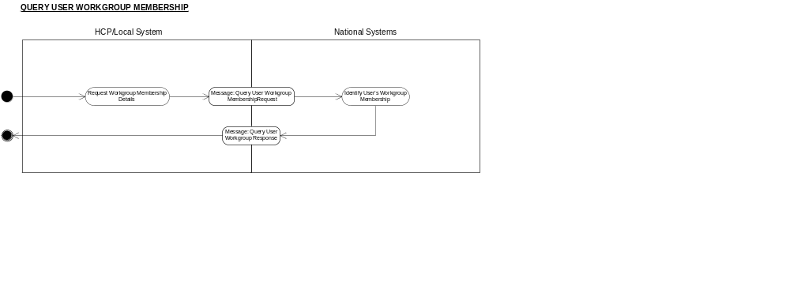

Business Transactions

Query User Workgroup Membership Request

Purpose
See Description and Clinical Scenario.

Business Communication Requirement

Communication Name | Query User Workgroup Membership Request
Sending Role | Request for User WG membership information
Trigger Event | A User acting in a URP may need to be joined to a Workgroup
Communication Type | Request
Receiving Role | Return the requested membership information

Business Communication Content

Level | Name  Item/Group | Definition | Example | Representation | Cardinality | Constraints & Dependencies | Default value | Null required | Outstanding issues
1 | Request Identifier | The unique identifier for the request message, generated by the system. |  | Format defined by Technical team:  UUID | 1
2 | User id | The SDS User identifier of the User whose membership is being queried | 123456789012 | Twelve character UID as defined by the SDS group | 1
3 | User Role Profile | The specific URP Id of the User identified above, with which the query is related. | 210987654321 | Twelve character UID as defined by the SDS group | 1
4 | Workgroup identifier | The Identifier of the Workgroup with which membership is being queried, or with which membership of a Workgroup hierarchically superior to it is being queried. |  | SDS allocated | 1
5 | Originating User Identifier | The unique identifier for the sending application’s logged on user at the time the request was made.  Required for audit and accountability purposes. | 123456789012 | Twelve character UID as defined by the SDS group | 1
6 | Originating system id | The id of the system that generated the request.  Used for audit purposes. |  | SDS id | 1

Query User Workgroup Membership Response

Purpose
The message is generated to inform the system of the outcome of a Query User Workgroup Membership Request.

Business Communication Requirement

Communication Name | Query User Workgroup Membership response
Sending Role | Returns requested information
Trigger Event | Request to identify the User’s Workgroup membership
Communication Type | Response
Receiving Role | N/A

Business Communication Content

Level | Name  Item/Group | Definition | Example | Representation | Cardinality | Constraints & Dependencies |  | Default value | Null required | Outstanding issues
1 | Requesting Message Identifier | The identifier for the message requesting the information. |  | Format defined by Technical team  UUID | 1
2 | Member of Nominated Workgroup | True if the User nominated in the requesting message is a member of the nominated Workgroup | “True” | Boolean | 1
3 | Start Superior Workgroup Membership Group |  |  |  | 0..1 |  | Present only if the Member of Nominated Workgroup field is “False”
3.1 | Member of Superior Workgroup | True if the User is a member of a Workgroup superior to the nominated Workgroup | “True” | Boolean | 1
3.2 | Superior Workgroup identifier | The Workgroup code of a superior Workgroup the User is a member of |  | SDS Allocated | 0..1 | Must be present only if the Member of a Superior Workgroup field is “True”
3.3 | Superior Workgroup Name | The Name of the Superior Workgroup the User is a Member of |  | Alphanumeric | 0..1 | Present only if the Member of a Superior Workgroup field is “True”
 | End Superior Workgroup Membership Group
4 | Failure Reason Code | A code denoting the reason for failure to provide the necessary information | 01 denotes  User not found | User not found with Id provided in Field Level 2  URP not found with URP Id provided  Workgroup not found with Workgroup Id provided | 0..1 | Will not be present if the operation was a success |  |  |  | Minimum code value set subject to change.

Add User to Workgroup

Description
This business communication requests that the user acting in the nominated User Role Profile (URP), is added to the nominated workgroup.

Clinical Scenario
There are a wide variety of reasons why a User Role Profile of a user will need to be added to a Workgroup. This will be required as new employees join an organisation and are assigned to teams, and thus by implication, to Workgroups. Existing employees will move from team to team, and therefore from Workgroup to Workgroup as demand for resources changes. Similarly, a peripatetic User, who may not be a regular member of any particular clinical team, can come on duty to work within a team on an ad hoc or otherwise temporary basis. One example is a bank nurse arriving to start a shift working on a ward, another might be a locum GP arriving to work at a GP practice. Such a User needs to be joined to the workgroup associated with the team when they report for duty in order that they can access the sensitive personal data of patients being cared for by that team. More precisely, the URP that the User will log on with when on duty must be joined to the team Workgroup.

Some NHS applications enable users to maintain the membership of certain types of team (e.g. practice team, ward team). The application managing the operation of the team (in the bank nurse example, this would be a ward management application) will require that new staff team members are registered as members of the application’s own internal representation of the team. If the joining operations to both team and workgroup are manually and separately performed there is a danger of them getting out of synch. The need for two manual actions would also seem unnecessary and onerous to users. This business communication enables the workgroup membership step to be automated. It is used by the application to join a user automatically to the appropriate workgroup at the time that user is manually joined to an application team.

There are also other application contexts in which this business communication can be used; for example it could also be used when an application wishes to present its own interface for users to manually join other users to a Workgroup.

Senders are expected to perform the access control checks necessary to verify that the action is authorised. Senders that are not RBAC enabled are not permitted to use this business communication.

The “Add User to Workgroup” business communication is complemented by the “Remove User from Workgroup” communication, whose message definitions follow.

Activity diagram
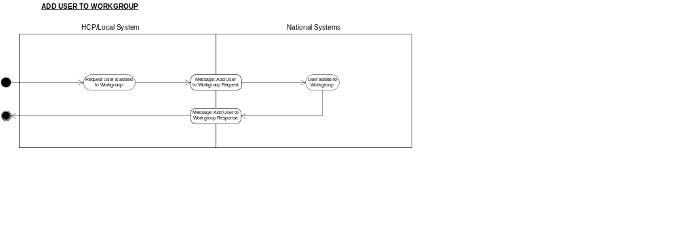

Business Transactions

Add User to Workgroup Request

Purpose
See Description and Clinical Scenario.

Business Communication Requirement

Communication Name | Add User to Workgroup Request
Sending Role | Request to add User, acting in the nominated URP, to Workgroup
Trigger Event | User acting in that URP needs to be joined to the Workgroup
Communication Type | Request
Receiving Role | Add the nominated Workgroup to the nominated URP

Business Communication Content

Level | Name  Item/Group | Definition | Example | Representation | Cardinality | Constraints & Dependencies | Default value | Null required | Outstanding issues
1 | Request Identifier | The unique identifier for the request message, generated by the system. |  | Format defined by Technical team:  UUID | 1
2 | User id | The SDS User identifier of the User being joined to the Workgroup | 123456789012 | Twelve character UID as defined by the SDS group | 1
3 | User Role Profile | The URP to which the Workgroup is to be added in order to represent the User as a member of that Workgroup  Note: What is seen in business terms as the addition of a URP to a workgroup, is in reality performed by adding the workgroup as a field of the URP. | 210987654321 | Twelve character UID as defined by the SDS group | 1
4 | Workgroup identifier | The Identifier of the Workgroup to which the User is to be added |  | SDS allocated | 1
5 | Originating User Identifier | The unique identifier for the sending application’s logged on user at the time the request was made.  Required for audit and accountability purposes. | 123456789012 | Twelve character UID as defined by the SDS group | 1
6 | Originating system id | The id of the system that generated the request  Used for audit purposes. |  | SDS id | 1

Add User to Workgroup Response

Purpose
The message is generated to inform the system requesting the joining of the User to the Workgroup of the outcome of the request.

Business Communication Requirement

Communication Name | Add User to Workgroup response
Sending Role | Add User to Workgroup
Trigger Event | User becomes part of team represented by the Workgroup or the action failed
Communication Type | Response
Receiving Role | N/A

Business Communication Content

Level | Name  Item/Group | Definition | Example | Representation | Cardinality | Constraints & Dependencies | Default value | Null required | Outstanding issues
1 | Requesting Message Identifier | The identifier for the message requesting the addition. |  | Format defined by Technical team  UUID | 1
2 | “Already a member” indicator | If present indicates that the Workgroup is already present in the identified URP, and that no action was taken. If not present, indicates that subject to there being no failure reason code, the request was successful and the URP was added to the workgroup | “Yes” | Boolean | 0..1 | Will not be present if no existing membership of the nominated Workgroup was found.  Will not be present if a failure reason Code is present.
3 | Failure Reason Code | A code denoting the reason for failure to add the User in the nominated URP to the nominated Workgroup | 01 denotes  URP not found | URP not found with URP Id provided  Workgroup not found with Workgroup Id provided | 0..1 | Will not be present if the operation was a success, or when the "Already a member" indicator has been set. |  |  | Minimum code value set subject to change.

Remove User from Workgroup

Description
Requests that the user acting in the nominated User Role Profile (URP), is removed from the nominated workgroup.

Clinical Scenario
See clinical scenario for Add User to Workgroup. The scenarios here are the reverse of those; as staff moved out of teams, they need to be removed from corresponding Workgroups. This message automates removal of a user from a Workgroup.

Activity diagram
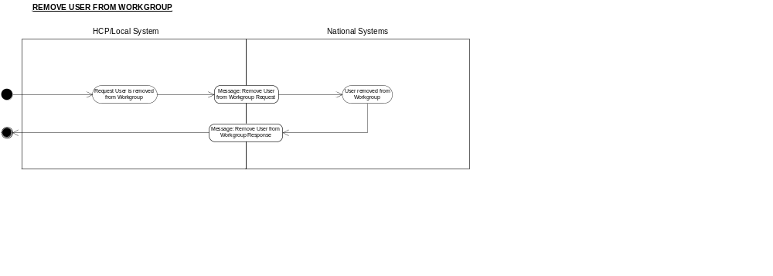

Business Transactions

Remove User from Workgroup Request

Purpose
See Description and Clinical Scenario.

Business Communication Requirement

Communication Name | Remove User from Workgroup
Sending Role | Remove User from Workgroup
Trigger Event | User is removed from the team represented by the Workgroup
Communication Type | Request
Receiving Role | Add User in the nominated URP to the nominated Workgroup

Business Communication Content

Level | Name  Item/Group | Definition | Example | Representation | Cardinality | Constraints & Dependencies | Default value | Null required | Outstanding issues
1 | Request Identifier | The unique identifier for the request message, generated by the system. |  | Format defined by Technical team:  UUID | 1
2 | User id | The SDS User identifier of the User being removed from the Workgroup | 123456789012 | Twelve character UID as defined by the SDS group | 1
3 | User Role Profile | The URP from which the Workgroup is to be removed in order to represent the User as a member of that Workgroup | 210987654321 | Twelve character UID as defined by the SDS group | 1
4 | Workgroup identifier | The Identifier of the Workgroup from which the User is to be removed |  | SDS allocated | 1
5 | Originating User Identifier | The unique identifier for the sending application’s logged on user at the time the request was made.  Required for audit and accountability purposes. | 123456789012 | Twelve character UID as defined by the SDS group | 1
6 | Originating system id | The id of the system that generated the request  Used for audit purposes. |  | SDS id | 1

Remove User from Workgroup Response

Purpose
The message is generated to inform the system requesting the removal of the User from the Workgroup of the outcome of the request.

Business Communication Requirement

Communication Name | Remove User from Workgroup Response
Sending Role | Remove User from Workgroup
Trigger Event | User is removed from the team represented by the Workgroup or the action failed
Communication Type | Response
Receiving Role | N/A

Business Communication Content

Level | Name  Item/Group | Definition | Example | Representation | Cardinality | Constraints & Dependencies | Default value | Null required | Outstanding issues
1 | Requesting Message Identifier | The identifier for the message requesting the removal. |  | Format defined by Technical team  UUID | 1
2 | “Was not a member” indicator | If present indicates that the Workgroup was not found in the identified URP, and that no action was taken. If not present, indicates that subject to there being no failure reason code, the request was successful and the URP was removed from the workgroup | “Yes” | Boolean | 0..1 | Will not be present if an existing membership of the nominated Workgroup was found.  Will not be present if a failure reason Code is present.
3 | Failure Reason Code | A code denoting the reason for failure to remove the User in the nominated URP from the nominated Workgroup | 01 denotes  URP not found | URP not found  Workgroup ID not found | 0..1 | Will not be present if the operation was a success, or if the "Was not a member" indicator has been set. |  |  | Minimum code value set subject to change.

